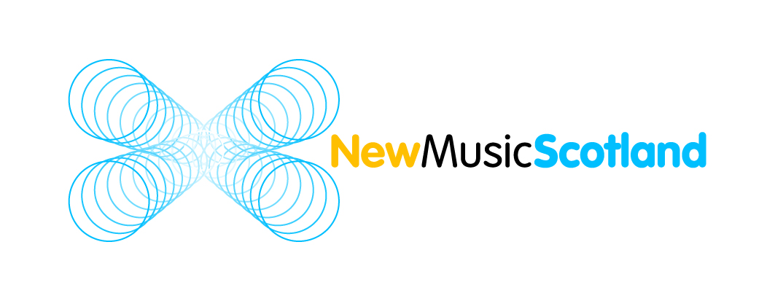
New Music Scotland Limited: Membership Form

Organisation:
(if relevant)
Name :
(contact name if organisation)
Address:

Postcode: |  | Tel number:
Email:

Website (if applicable):

Occupation  (tick as many as applicable | composer promoter producer  performer sound artist  other (please specify) _______________________________
Other relevant skills  (NMS aims where possible to employ its own members to undertake projects) | marketing web design social media  PR admin fundraising  graphic design sound engineer recording engineer  sound designer visual artist  Other (please specify): ________________________________

Important: New Music Scotland Limited is a co-operative.
Please note that both boxes below must thus be signed to become a member.

I have read the New Music Scotland Limited Membership agreement & wish to subscribe to it:  (signature)  (date)  On behalf of (if organisation): | I have read the Memorandum of Association, wish to subscribe to it, & agree to become a member of New Music Scotland Limited:  (signature)  (date)  On behalf of (if organisation):

Subscription (upon joining)
The amounts below are minimum recommended. You are welcome to give more to support NMS functioning costs!

Students £5 + Individuals £20 + Organisations £30 +

Cheques made payable to New Music Scotland Ltd

Transfer details: Co-operative Bank - Account holder: New Music Scotland Limited -
Sort code: 089299 - Account number: 65693656
Please return signed form (& payment) to: NMS, c/o Woodend Barn, Banchory AB31 5QA

